|  |  |
| --- | --- |
|  | Solar Light Project |

The Problem – Non-Rechargeable Batteries

***Powering an LED light from a non-rechargeable battery is harmful to the environment and expensive to power for long periods.***

**How can we make an LED light more reusable, sustainable, and inexpensive to use for hundreds or thousands of hours?**

The Solution – Solar Powered Rechargeable Battery

There are many possible solutions to the problem of non-rechargeable batteries, including powering the light directly from a wall plug or using rechargeable batteries. We’ve chosen to explore powering the LED light from a solar-powered rechargeable battery as a promising solution to the problem.

Solar panels can recharge a battery anywhere using the sun. They are portable, reliable, inexpensive, and widely accessible.

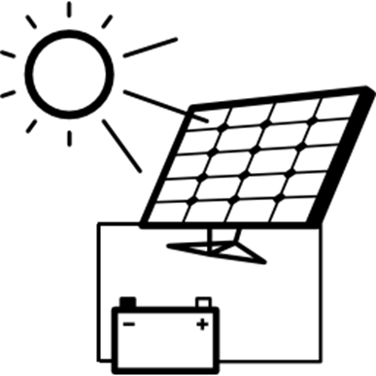[[1]](#footnote-1)

**We will be building an LED light powered by a small rechargeable battery and solar panel.**

Needs and Constraints

Needs

The light must:

1. Light one white LED (5mm) for 6 hours at full brightness (50mW).
2. Fully recharge in 6 hours under typical sunny conditions.

Constraints

Some limitations for our design include:

* Time: The light must be built in fewer than seven 1-hour activity sessions
* Materials:

|  |  |  |
| --- | --- | --- |
| 1x | C:\Users\Harryp\MEGA\Surface Pro 2\Nepal\Himalayan Makers Guild\Activities\Projects\Project Solar\images\part 4v battery.JPG | Lead-Acid Battery (4V, 1Ah) |
| 1x | C:\Users\Harryp\MEGA\Surface Pro 2\Nepal\Himalayan Makers Guild\Activities\Projects\Project Solar\images\2018-05-04 18_48_14-Untitled Sketch.fzz_ - Fritzing - [Breadboard View].jpg[[2]](#footnote-2) | 5mm LED (White) |
| 1x |  | Diode (1N4001) |
| 2x | C:\Users\Harryp\MEGA\Surface Pro 2\Nepal\Himalayan Makers Guild\Activities\Projects\Project Solar\images\part solar panel.JPG | Solar Panel  (3V, 120mA, 6cm x 6cm) |

Basic electronic components (wires, resistors, capacitors, etc.), breadboards, and basic building supplies (cardboard, glue, tape, etc.) will also be available for building the light.

1. Solar icon modified from an icon by [Freepik](http://www.freepik.com) from [www.flaticon.com](https://www.flaticon.com/) is licensed by [CC 3.0 BY](http://creativecommons.org/licenses/by/3.0/) [↑](#footnote-ref-1)
2. Part Images from Fritzing [↑](#footnote-ref-2)